# More Exercise: Functions and Forms

Problems for in-class lab for the [“Technology Fundamentals” course @ SoftUni](https://softuni.bg/trainings/2056/technology-fundamental-september-2018#lesson-9622).

Submit your solutions in the SoftUni judge system at: [Functions-and-Forms-More-Exercise](https://judge.softuni.bg/Contests/1292/Functions-and-Forms-More-Exercise)

# Functions

## Car wash

Write a JS function that receives some commands. Depending on the command add a percentage of how much the car is cleaned. Start from 0. The first command will always be 'soap':

* soap – add 10 to the value
* water – increase the value with 20%
* vacuum cleaner – increase the value with 25%
* **mud** – decrease the value with 10%

The **input** comes as an **array strings**. When finished cleaning the car, print the resulting value in the format:  
**"The car is {value}% clean.".** The value should be rounded to the second decimal point.

### Examples

|  |  |
| --- | --- |
| **Input** | **Output** |
| ['soap', 'soap', 'vacuum cleaner', 'mud', 'soap', 'water'] | The car is 39.00% clean. |

## Number Modification

Write a JS program that modifies a number until the average value of all its digits is **higher than 5**. To modify the number, your program should append a **9** to the end of the number, when the average value of all its digits is **higher than 5** the program should stop appending. If the number’s average value of all its digits is already **higher than 5**, no appending should be done.

The **input** is a single number.

The **output** should consist of a single number - the final modified number which has an average value of all its digits **higher than 5**. The **output** should be printed on the console.

### Constraints

* **The input number will consist of no more than 6 digits.**
* **The input will be a valid number (there will be no leading zeroes).**

### Examples

|  |  |
| --- | --- |
| **Input** | **Output** |
| 101 | 1019999 |
| 5835 | 5835 |

## Points Validation

Write a JS program that receives two points in the format **[x1, y1, x2, y2]** and checks if the distances between each point and the start of the cartesian coordinate system (0, 0) and between the points themselves is **valid**. A distance between two points is considered **valid**, if it is an **integer value**. In case a distance is valid write "**{x1, y1} to {x2, y2} is valid"**, in case the distance is invalid write **"{x1, y1} to {x2, y2} is invalid"**.

The order of comparisons should always be first **{x1, y1}** to **{0, 0}**, then **{x2, y2}** to **{0, 0}** and finally **{x1, y1}** to **{x2, y2}**.

The **input** consists of two points given as an array of numbers.

For each comparison print on the **output** either "**{x1, y1} to {x2, y2} is valid"** if the distance between them is valid, or **"{x1, y1} to {x2, y2} is invalid"**- if it’s invalid.

### Examples

|  |  |
| --- | --- |
| **Input** | **Output** |
| [3, 0, 0, 4] | {3, 0} to {0, 0} is valid  {0, 4} to {0, 0} is valid  {3, 0} to {0, 4} is valid |
| [2, 1, 1, 1] | {2, 1} to {0, 0} is invalid  {1, 1} to {0, 0} is invalid  {2, 1} to {1, 1} is valid |

## Radio Crystals

You need to write a JS program that monitors the current thickness of the crystal and recommends the next procedure that will bring it closer to the desired frequency. To reduce waste and the time it takes to make each crystal your program needs to complete the process with the least number of operations. Each operation takes the same amount of time, but since they are done at different parts of the factory, the crystals have to be transported and thoroughly washed every time an operation different from the previous must be performed, so this must also be taken into account. When determining the order, always attempt to start from the operation that removes the largest amount of material.

The different operations you can perform are the following:

* Cut – cuts the crystal in 4
* Lap – removes 20% of the crystal’s thickness
* Grind – removes 20 microns of thickness
* Etch – removes 2 microns of thickness
* X-ray – increases the thickness of the crystal by 1 micron; this operation can only be done once!
* Transporting and washing – removes any imperfections smaller than 1 micron (round down the number); do this after every batch of operations that remove material

At the beginning of your program, you will receive a number representing the desired final thickness and a series of numbers, representing the thickness of crystal ore in microns. Process each chunk and print to the console the order of operations and number of times they need to be repeated to bring them to the desired thickness.

The **input** comes as a numeric array with a variable number of elements. The first number is the target thickness and all following numbers are the thickness of different chunks of quartz ore.

The **output** is the order of operation and how many times they are repeated, every operation on a new line. See the examples for more information.

### Examples

|  |  |
| --- | --- |
| **Input** | **Output** |
| [1375, 50000] | Processing chunk 50000 microns  Cut x2  Transporting and washing  Lap x3  Transporting and washing  Grind x11  Transporting and washing  Etch x3  Transporting and washing  X-ray x1  Finished crystal 1375 microns |

## Print DNA

Write a JS program that prints a DNA helix with length, specified by the user. The helix has a repeating structure, but the symbol in the chain follows the sequence ATCGTTAGGG. See the examples for more information.

The **input** comes as a single number. It represents the length of the required helix.

The **output** is the completed structure, printed on the console.

### Examples

|  |  |  |  |  |
| --- | --- | --- | --- | --- |
| **Input** | **Output** |  | **Input** | **Output** |
| 4 | **AT** *C--G* T----T *A--G* | 10 | **AT** *C--G* T----T *A--G* **GG** *A--T* C----G *T--T* **AG** *G--G* |

# Forms

## Registration Form

Create a form for registration. At the end it should look like this:

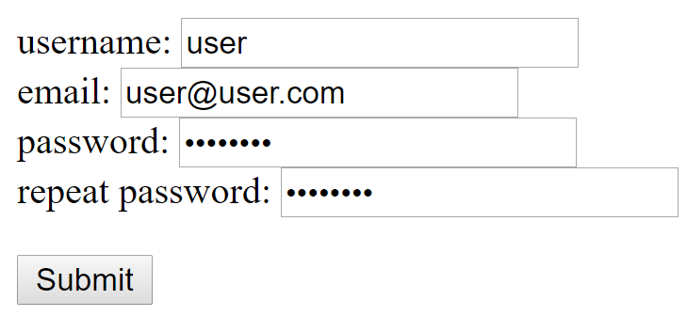

There are some rules for each field:

* The **username** field should **not be empty** and should be **at least 4 symbols**
* The **email** field should **contain '@'** and **'.com'** and **at least 4 more symbols**
* The **password** should be **at least 6 symbols**
* The **repeat password** should be **the same as the password**

Errors for each **wrong input attach a paragraph** with an **error message** (can be **more than one**):

* 'Username should be at least 4 symbols'
* 'Invalid email'
* 'Password should be at least 6 symbols'
* 'Passwords do not match'

The **error message text should be red**

If **everything is valid** there should be only **one message 'Welcome {username}!'** The message should be **in green**

### Example

|  |  |
| --- | --- |
| **Input** | **Output** |
| AsD  asd@asd.com  pass  password | **Username should be at least 4 symbols**  **Invalid email**  **Password should be at least 6 symbols**  **Passwords do not match** |
| CoolUser  CoolUser@mail.com  ValidPassword  ValidPassword | **Welcome CoolUser!** |

## Hotel Stay

Create a form that receives a quantity of people, the type of the stay and the nights of the stay. At the end, the form should look something like this:

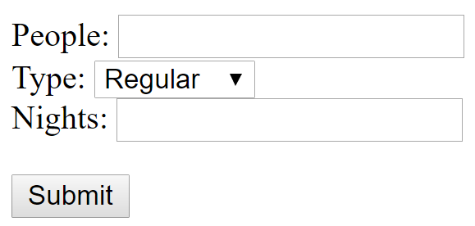

There are different prices depending on the type of the stay. Here are the prices for a single person for one night:

|  |  |
| --- | --- |
| **Regular** | 25 |
| **Business** | 31 |
| **VIP** | 45 |

Calculate the total price for all the people and add it as paragraph to the body of the html with message 'Total money: {money}'. The money should be formatted to the second decimal point.

### Example

|  |  |
| --- | --- |
| **Input** | **Output** |
| 15  Regular  8 | Total money: 3000.00 |
| 5  VIP  14 | Total money: 3150.00 |

## **Shopping Cart

Create form that allows a user to choose different **items to add to his cart**. When the button is clicked, **calculate the total money and write it in a special field 'Total price'**. Here is a table with all the items and their price for **a single piece**. (there also should be a **field for quantity**)

|  |  |  |  |
| --- | --- | --- | --- |
| **TV** | **Sofa** | **Fridge** | **Bed** |
| 1000.30 | 570.60 | 860.70 | 450.50 |

At the end the form should look like this:

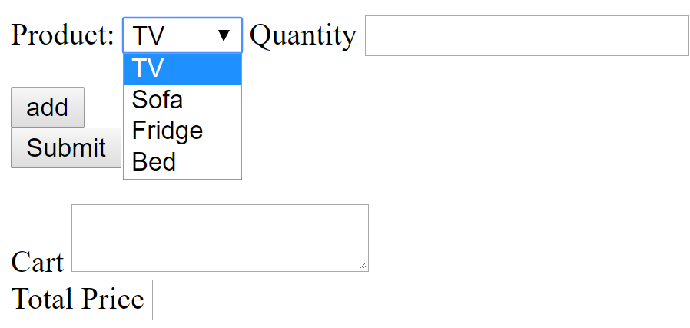

* You should have **'add' button** to add something to the cart (use onclick to **execute an add function**)
* When the button **add is clicked**, and **a quantity is chosen,** **add a line in the cart in the following format '{quantity} X {product}'**
* When the button **'Submit'** is pressed calculate the **total price and write it in the Total Price field**

### Constrains

* Use **id 'cart'** for the Cart field
* Use **id 'totalPrice'** for the Total Price field

### Hint

* When clicking 'Submit' split the text in the cart by new line and loop through each element (splitting will create an array/list of elements you can loop through)
* When looping split each element by ' X ' to get the quantity and the product

### Example

|  |  |
| --- | --- |
| **Input** | **Output** |
| 1 X TV  2 X Sofa  1 X Fridge | 3002.2 |
| 2 X Bed  1 X Sofa  5 X TV  2 X Fridge | 8194.5 |